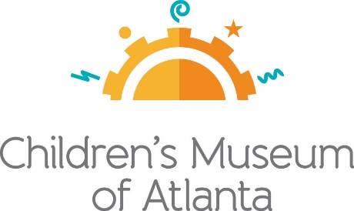

FOR MORE INFORMATION:
Sarah Wynn Benton
BRAVE Public Relations
404.233.3993
sbenton@emailbrave.com

PNC Bank Commits Five Year Sponsorship to the ‘Tournament for PLAY’ Fundraiser Benefitting the Children’s Museum of Atlanta
PNC’s regional president Eddie Meyers selected to chair 10th annual golf tournament
ATLANTA – (Feb. 18, 2022) – On August 29, golfers will once again hit the green for the Children’s Museum of Atlanta’s 10th Annual ‘Tournament for PLAY.’ To commemorate the anniversary, PNC Bank has pledged a five-year commitment of nearly $300,000 for the fundraiser, which generates financial support for more than 200,000 children and caregiver programs each year. Presented by PNC Bank, the golf tournament benefits the Museum’s educational exhibits and community outreach programs. This year, Eddie Meyers, PNC regional president of Georgia, will chair the tournament held at the renowned Peachtree Golf Club.
“The annual ‘Tournament for PLAY’ is a celebration of relationships that ultimately benefits our community through innovation, education and dynamic children’s programs offered at the Museum and throughout Atlanta,” said Meyers. “At PNC, we are a strong believer in the value of early childhood education and know that what the Children’s Museum offers daily through the arts and sciences will also make a lasting difference in the future.”
The philanthropic sporting event enables golfers to support a world of hands-on exploration and discovery that sparks imagination and inspires learning, while playing the sport they love. The Museum is continuously dedicated to bringing its mission to life, by igniting a sense of discovery and learning through the power of play. Sign-ups for participation and sponsorships for this year’s tournament are now available on the Museum’s website.
“The Tournament for PLAY would not be what it is today without PNC Bank’s continued commitment and extreme generosity,” said Children’s Museum of Atlanta Executive Director Jane Turner. “We are eternally grateful to our kind, supportive previous golfers and sponsors and are excited to announce participant sign ups and sponsorship opportunities are now available. As the tournament sells out annually, it continues to raise impactful funds for the Museum to offer the necessary and engaging educational, yet playful, programs children need to learn and develop.”
For more information about sponsorships, businesses may contact Laura Halad at lhalad@childrensmuseumatlanta.org. Event registration is available on the Children’s Museum of Atlanta website.
###
About PNC Bank:
PNC Bank, National Association, is a member of The PNC Financial Services Group, Inc. (NYSE: PNC). PNC is one of the largest diversified financial services institutions in the United States, organized around its customers and communities for strong relationships and delivery of retail and business banking, including a full range of lending products; specialized services for corporations and government entities, including corporate banking, real estate, finance and asset-based lending; wealth management. For information about PNC, visit www.pnc.com

About Children’s Museum of Atlanta:
Children’s Museum of Atlanta is the only educational venue of its kind in Atlanta, presenting educational programs and exhibits designed for young children ages birth to 8. The Children's Museum of Atlanta aims to change the world by sparking every child's imagination, sense of discovery and learning through the power of play. With learning zones consisting of bright, creative and hands-on exhibits, the Museum supports inventive play-based exploration and experiential learning focused on the whole child. Core competencies for literacy, math and science are promoted throughout all exhibits and programming in alignment with the state and national Core Performance Standards.
Museum Admission: Online ticketing only is available at this time. Phone booking is available with ample notice and will be booked via online reservation. Members must pre-book and will be able to redeem their $5 voucher online. Babies 11 months and younger and members are admitted for free and must reserve their free ticket online prior to arriving at the Museum. All daily programs are included in price of admission. For more information regarding ticket and membership options, visit childrensmuseumatlanta.org or call 404.659.KIDS [5437].

